**DAILY REPORT**

**Student Name :SINDHU.N**

**Class and Sec : VI B**

**USN :4AL17CS094**

**DATE:28-07-2020**

|  |  |  |  |  |
| --- | --- | --- | --- | --- |
| **Online Test Details** | | | | |
| **Subject** | OR | | | |
| **Semester** | VI -B | | **Duration** | 90Minutes |
| **% of marks**  30 | | ---- | | |

|  |  |  |  |
| --- | --- | --- | --- |
| **Certification Course Details** | | | |
| **Course** | Python for Everybody | | |
| **Certificate Provider** | Coursera | **Duration** | 19hours |

**Snapshots of the daily class acitivities .**

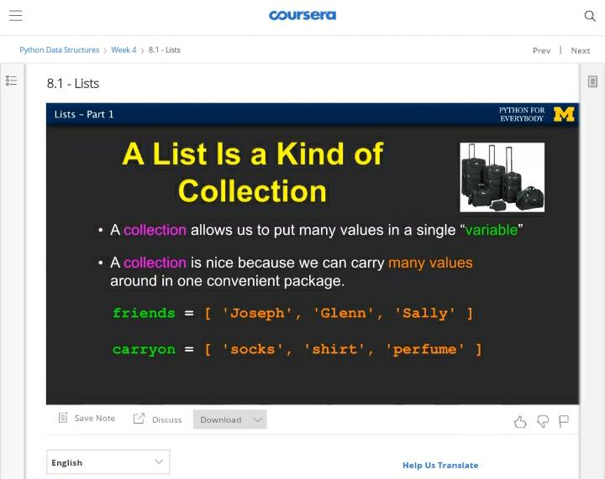

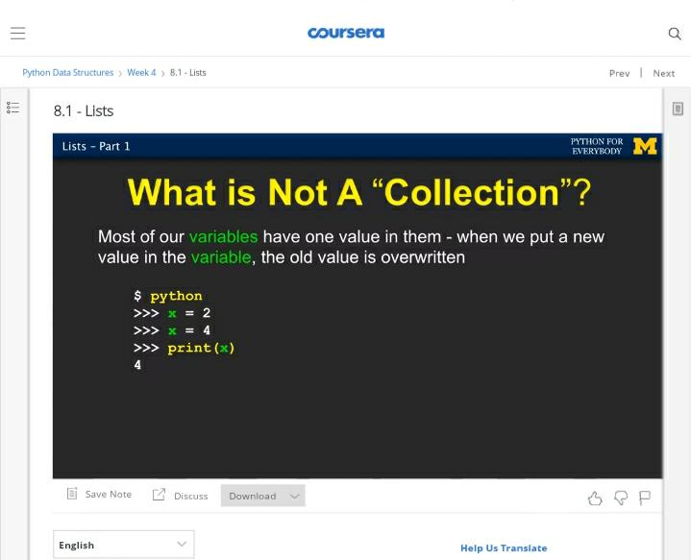

|  |  |
| --- | --- |
| **Coding Challenges** | |
| **Problem Statement:** 1.**Python Program for Print Number series without using any loop.** | |
| **Status:** Executed | |
| **Uploaded the report both in Github & Slack** | Yes |

**Snapshots of your response to challenge.**

**1.**Python Program for Print Number series without using any loop.****

def PrintNumber(N, Original, K, flag):

print(N, end = " ")

if (N <= 0):

if(flag==0):

flag = 1

else:

flag = 0

if (N == Original and (not(flag))):

return

if (flag == True):

PrintNumber(N - K, Original, K, flag)

return

if (not(flag)):

PrintNumber(N + K, Original, K, flag);

return

N = 20

K = 6

PrintNumber(N, N, K, True)

**OUTPUT**

